


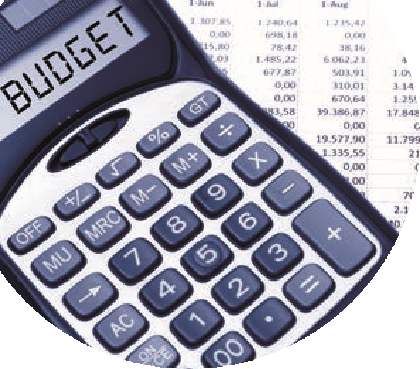
BOM Monthly Reports from BrightBooks
Final accuracy checklist
 | Month end reports | Comments | Month:XX 202X  Checked
D  A  T  A  C  H  E  C  K | Run the Simple TB to ensure the totals match for debits and credits | A standard accounting check to ensure the accuracy of the figures before running final reports | Let the FSSU know also
D  A  T  A  C  H  E  C  K |  | If for any reason the totals do not agree / Run the Nominal Only Recalculation under settings / Data (see further information below) | Let the FSSU know also
D  A  T  A  C  H  E  C  K | Re run the Simple TB and check that  the totals match | If there is still a problem contact the BrightBooks support team for a resolution | Let the FSSU know also
After running the Simple TB for accuracy check on Data
Run the BOM Monthly reporting pack
Follow the guidance points below on cross checking of reports
1 | A list of balances on all school bank and cash accounts | Bank codes in the simple trial balance | ü
2 | Bank Reconciliation  Bank reconciliation report for all school bank accounts | Check that the balance as per BrightBooks agrees to the relevant bank balance in the Balance sheet & in the Simple Trial Balance report  Outstanding items reviewed for accuracy. Duplicates or errors are corrected | ü  ü
3 | Income & Expenditure report | The final Net Profit/ Loss should agree to the Income & expenditure figure showing at the end of the Capital & Reserves section at the bottom of the Balance Sheet | ü
4 | Balance sheet report | Cumulative balances to the month end being reported on.  The bank rec reports and the Aged Creditor balances should also be generated to this same month end date and balances should always be cross checked | ü
5 | List of Supplier balances | The total of this list should agree to the balance in code 2100 in the Balance sheet at the month end | ü
6 | List of Accruals/Income in advance/prepayments | Department report for Income in advance and total to agree to balance in code 2105.  Listing of prepayments agreed to balance in code 1720.  Listing of accruals agreed to balance in code 2440. | ü
7 | Capital Income & Expenditure account report (if applicable). | Info generated from a department report from BrightBooks which analyses the movement on the various nominal accounts | ü

Simple Trial Balance (TB) report in BrightBooks:
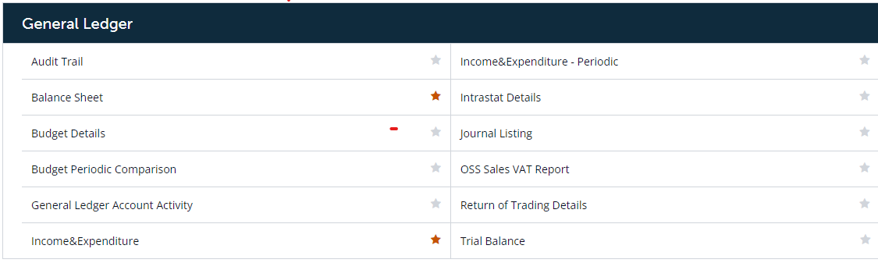

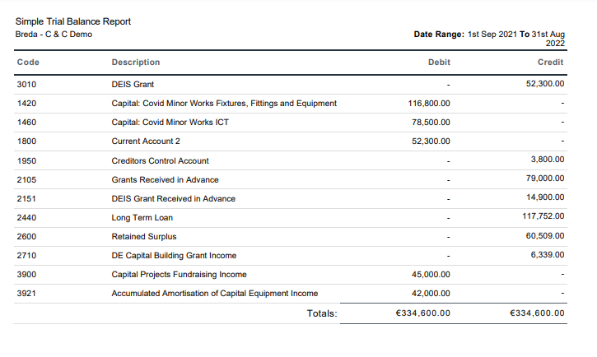
Example of a Simple Trial Balance (TB) report

Nominal Only Recalculation:
The new Nominal Recalculation feature that has been introduced allows you to re-calculate the current year's nominal balances only. It however does not take into consideration the comparative years or the customer and supplier ledgers. To re-calculate the current year's nominal balances, complete the steps.
1. In the top right corner, click Settings.
2. The Settings page appears. Under the DATA heading, click Nominal Only Recalculation.
3. A pop-up message is displayed that states; " This Re-calculation routine will recalculate the current year nominal balances ONLY. It will NOT recalculate the comparative year or the customers and suppliers ledgers". Click OK to continue.
4. Once the calculation is completed, a validation message is shown.
5. If there is no nominal validation for the selected business, a message is shown.
