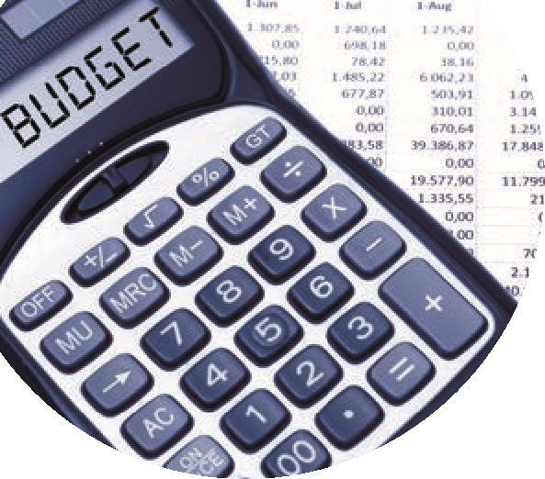

**Accounting for Junior Cycle Free Schoolbooks Grant & Expenses in BrightBooks**

|  |  |  |
| --- | --- | --- |
| Option 2 on FG 24/25 - 03 | | |
| Financial Year ending August 2024 | | |
| Year-end Closing Balances | **Financial Guideline 23/24 No 24**  Accounting for Junior Cycle Schoolbooks Scheme Grant and Administration Support Grant | **Summary**   * Create a department * Grant Receipt posted to 2151 – Book grant received in advance * Expenses posted to 1720 – Prepayments |
| New Financial Year – September 2024 – August 2025 | | |
| 1. Opening Balances @ 1.9.2024 – *Option 2 on FG 24/25 – 03* | | |
| Nominal code | **Details** | **BrightBooks** |
| 1720 | Move the cost of books purchased in 23/24 relating to 24/25 from Balance Sheet to expense code 4731 or 4113 where appropriate | Journal dated 1.9.2024  Dr: 4731 Free Schoolbook grant expense  Dr: 4113 Free Schoolbook admin salary expenses  Cr: 1720 Prepayments |
| 2151 | Journal required to move Junior cycle book grant to code 3151 | Journal dated 1.9.2024  Dr: 2151 –Book grant received in advance  Cr: 3151 – Total JC Free Schoolbook grant |
|  | Journal required to move Junior cycle admin grant to code 3152 | Dr: 2151 – Book grant received in advance  Cr: 3151 – Total Free Schoolbook admin grant |
| 1. Recording Expenditure funded by Junior Cycle Grant in BrightBooks in 24/25 | | |
| Purchases | * Books & Resources | Quick Purchase Invoice in BrightBooks  Code to 4731- Free Schoolbook grant expense |
| Banking | * Payroll costs including revenue costs | Quick Payment in BrightBooks  Debit 4113 Free Schoolbook admin salary expenses  Credit Payroll accounts on balance sheet |
| or |  |  |
| Journals | * Payroll costs including revenue costs | Journal in BrightBooks  Code to 4113 Free Schoolbook admin salary expenses |
| 1. BOM Monthly report of unspent amount of Free Schoolbooks grant   Run a monthly department report for the Free Schoolbooks grant showing spend to date | | |
| 1. At Year ending Aug 2025 Calculate value of unspent Free Schoolbooks grant   Value in code 3151/3152 less value in cost codes 4113/4731 = unspent grant.  Use journal entry to credit code 2160 & debit respective grant codes 3151/3152 with unspent amounts | | |