BrightBooks for C&C Schools

**Quick Reference Guide**

**Closing out the Financial Year 2023/24 on BrightBooks**

**WARNING-THIS PROCESS IS NOT REVERSABLE**



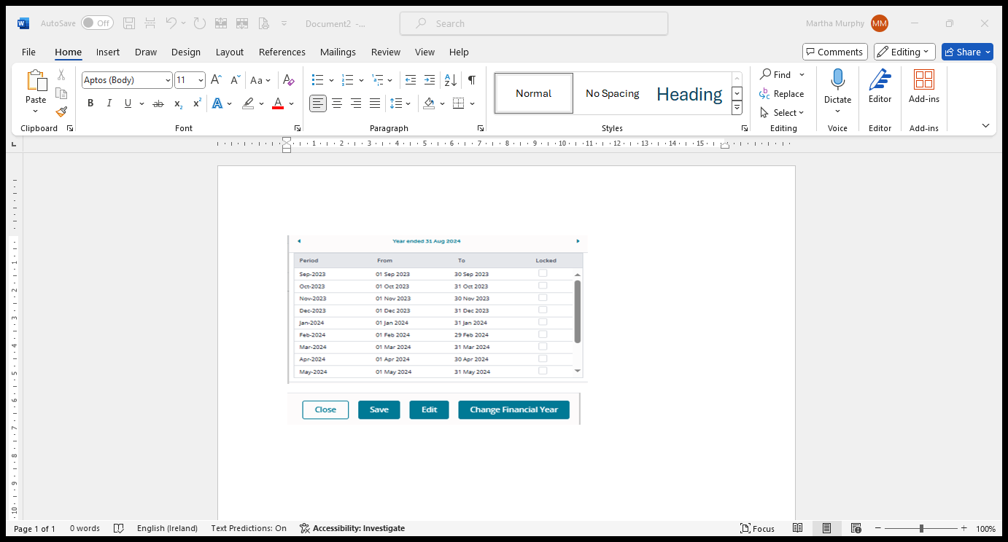

Step 1

Check the Financial Year End on BrightBooks

**Instructions**

Click on Settings > Click Accounting Periods

* Year Ended 31 Aug 2025 - No further action required.
* Year Ended 2024 - Move to Step 2

Step 2

When you can answer YES to these four questions - Move to step 3

1. Has the board of management signed off on the annual accounts for the year ended 31st August 2024?
2. Has the external accountant/auditor submitted the annual accounts for the year ended 31st August 2024 to the FSSU?
3. Has the external school accountant/auditor prepared and posted/or provided adjustments to BrightBooks?
4. Confirm with the external school accountant/auditor that all adjustments are completed prior to running the year end routine.

*To answer YES*

*please tick the box*

Step 3

Take a Back Up

**Instructions**

* Click on Settings > Click Export
* On the Data Export Message > Click OK
* A download file will appear at the bottom of the screen or in your list of downloads.
* Save this to the cloud or a USB stick.
* Move to Step 4

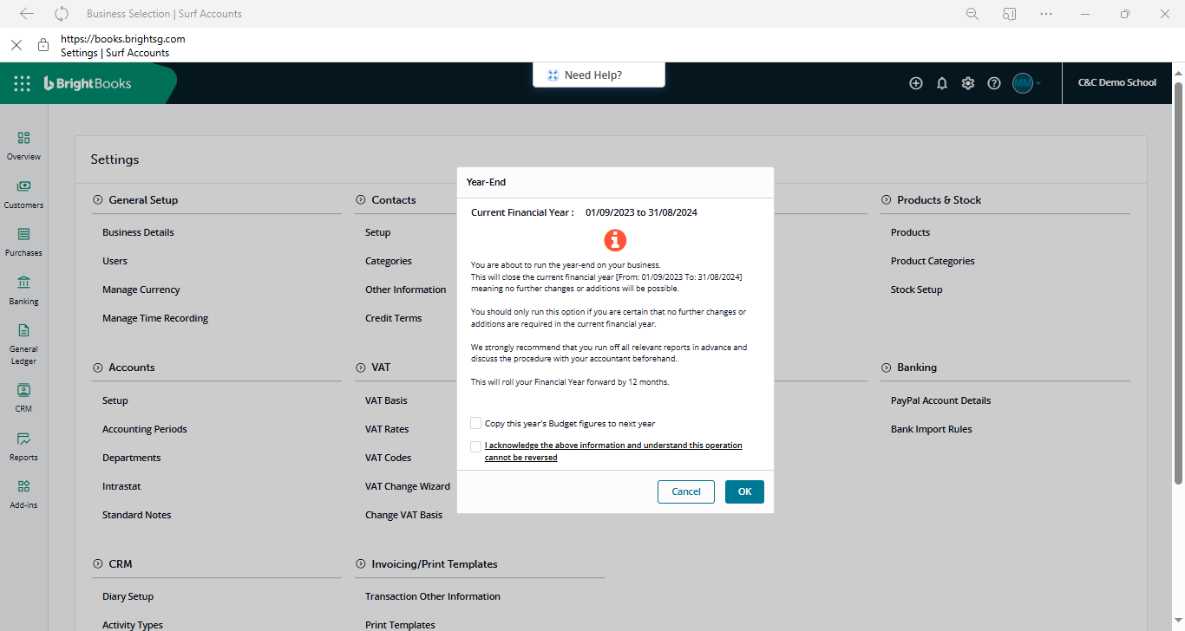

* The information message window confirms the year end completion.
* Move to Step 5

Step 5

Confirm the Year End has been changed.

**Instructions**

1. Click Settings > Click Accounting Periods
2. The Year ended date should show 31 Aug 2025

Step 4

Run the Year End

**Instructions**

* Click Settings > Click Year End
* The Year-End window appears. Read the messages carefully. **Note that the process is irreversible.**
* Tick 'I acknowledge the above information and understand this operation cannot be reversed’.
* Enter the "RUN YEAR END" as shown in the diagram.
* Click the OK button.
* A confirmation message window will appear asking "Are you sure you wish to run Year-End routine?".
* To proceed, click OK.

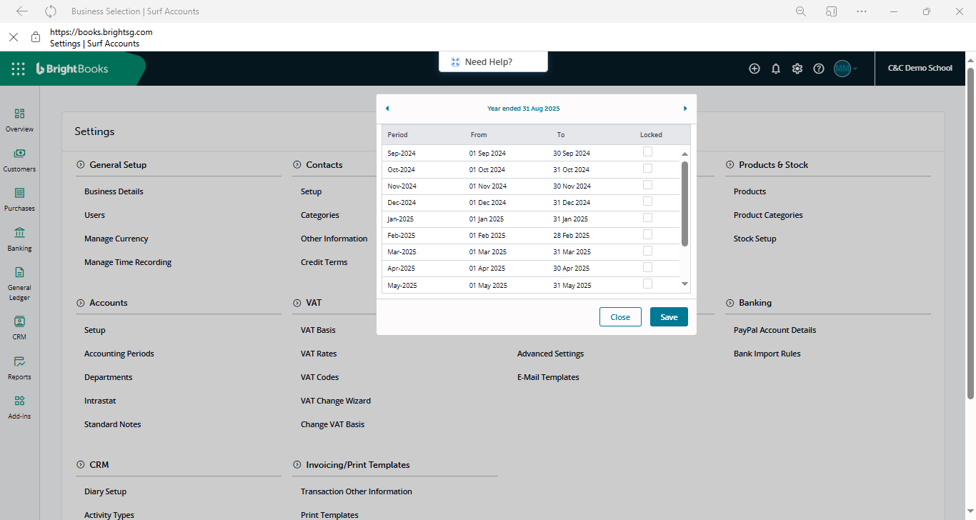

Step 6

1. Perform a data check by running a Nominal only recalculation

**Instructions**

* + - Click Settings > Data > Nominal Only Recalculation

1. Run the Simple Trial Balance report to ensure the totals match for debits and credits

**Instructions**

* + - Click Reports> Nominal ledger > Trial Balance

If there are any validation errors in step A above please email the details to BrightBooks at [brightbookssupport@brightsg.com](mailto:brightbookssupport@brightsg.com) and [info@fssu.ie](mailto:info@fssu.ie).

BrightBooks will notify via email when the validations are cleared

[Click **here** to watch a short video on the above process of closing out the year end](https://www.fssu.ie/post-primary/topics/surf-accounts/training-videos/financial-year-end-surf-accounts/rolling-over-the-year-end/).

FSSU, Emmet House, Dundrum Road, Milltown, Dublin 14. **Tel:** 01 269 0677 **Email:** info@fssu.ie