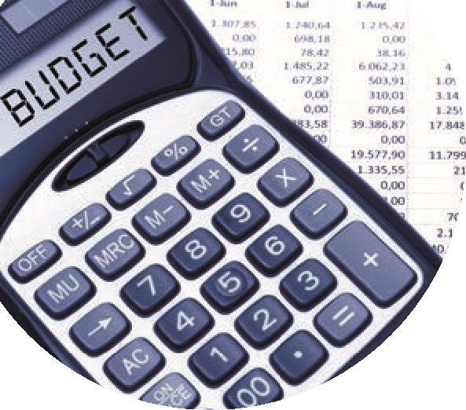

BOM Monthly Reports from Sage 50 Accounts

Accuracy Checklist

Along with suggested Batch Reports for Principal or Finance Committee

|  | Month end reports | What should be checked prior to issuing to BOM | Batch Reports |
| --- | --- | --- | --- |
| 1 | A list of balances on all school bank and cash accounts | Run from the print list in the Bank module. The bank balance showing here is always the latest bank balance at time of printing. | 1.Trial Balance |
| 2 | Bank reconciliation report for all school bank accounts | Check that the *Cashbook balance* in this report agrees to the relevant bank balance in the *Balance sheet*  Outstanding items reviewed for accuracy. Duplicates or errors are corrected | 1 O/S ITEMS |
| 3 | Income & Expenditure report | The final net profit/loss should agree to the Income & expenditure figure showing at the end of the Capital & Reserves section in the Balance Sheet | 2.Income & Expenditure Account +  Nominal activity report |
| 4 | Balance sheet report from B/F | Cumulative balances to the month end being reported on.  The bank rec reports and the Aged Creditor balances should also be generated to this same month end date and balances should always be cross checked | 3. Balance sheet |
| 5 | List of Supplier balances | The total of this list should agree to the balance in code 2100 in the Balance sheet at the month end | 1. Suppliers ledger |
| 6 | List of Accruals/Income in advance/prepayments | * Department report for Income in advance and total to agree to balance in code 2105. * Listing of prepayments agreed to balance in code 1720. * Listing of accruals agreed to balance in code 2440. | 1. Nominal activity for required codes |
| 7 | Capital Income & Expenditure account report (if applicable). | Info generated from a department report from Sage which analyses the movement on the various nominal accounts | Balance sheet + nominal activity for 14xx +  39xx codes |

|  |  |
| --- | --- |
| A batch report is a collection of reports that can be viewed, printed, emailed or exported together. If you regularly produce the same set of reports for the finance committee or the principal by combining them into a batch saves time | |
| **Favourites** | **Best to have all key reports highlighted as a favourite in Sage 50** |
| **Tools** |  |
| Batch report |  |
| New | Add name and description |
| Favourites or reports | Select the required reports to batch print |
| BOM RP 1 | Trial Balance/BS/I&E/Suppliers/Bank |
|  | Save |
|  |  |
|  |  |

# Screenshots for guidance for BOM RP 1

Select the appropriate reports and click Add

Select the appropriate criteria values (remember that Balance sheet is always from brought forward to month being reported on)

The batch reports can be printed or exported to required format for distribution to the Principal or Finance Committee

# Screenshots for Batch report of BOM Income & Expenditure account and their related nominal activity accounts

# Screenshots for Batch report of BOM Balance sheet and the related nominal activity accounts for a capital project

# Screenshots for Batch report of BOM Balance sheet and the related nominal activity accounts along with the department reports for a capital project

# Screenshots for Batch report of BOM Balance sheet and the related nominal activity accounts along with the department reports for Income received in advance code

