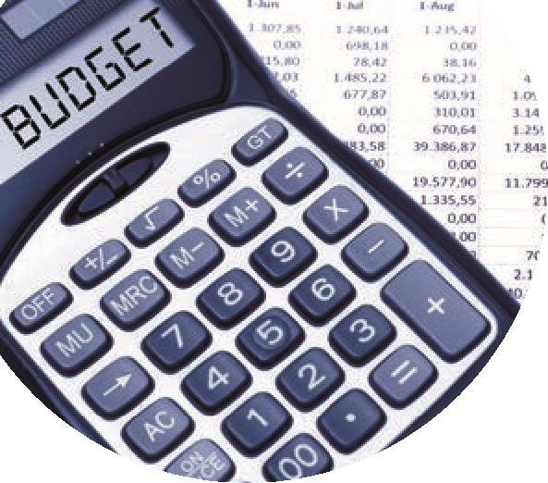

New Financial Year 2023/2024
Completing Year end in Sage 50- Checklist
 | Follow up | Detail
1 | Are the draft accounts available from the accountant?  Are the Y/E adjustments available? | Yes?  Record the Year end adjustments in Sage 50  Ensure Sage TB = Accountants TB
 | Review nominal activity for new financial Year. | Income & expenditure codes  Balance sheet codes – accruals 7 prepayments
or | Are the draft accounts / year end adjustments available from the accountant? | No  Do not put off running Y/E
2 | Run Year end in Sage 50
 | Tools  Period end  Year end | 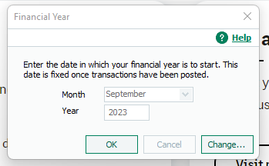
3 | Import the Budget for 23/24
4 | Run the proper BOM reports  Always run Balance sheet report from BF | 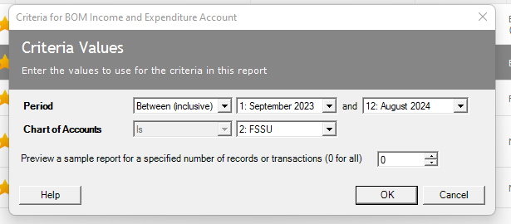
5 | Ensure that the journals @1.9.2023 are recorded in Sage 50 | Income in advance/Accruals/Book Grant/Prepayments
6 | Ensure you get the year end journals from Accountant | Record them in Sage and only update Balance sheet codes

