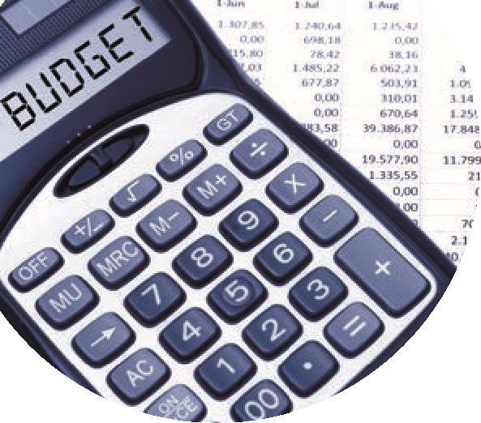

Capital Project Checklist
For SURF Accounts Users
 | Event | TASK | Handouts
 | Overview of Capital Projects  Register contract in ROS | - Set-up Files  - Capital Project File  - RCT  - VAT  - Budget information for template  - Check COA for most recent version – with reference to contribution to FA | - Capital Project Template  - Supplier Set-up Form  - Current FSSU COA
 | Steps on SURF | - Create department for Capital Project  - Record DE Grant in SURF (Use Dept)  - Set-up supplier – tick RCT Subcontractor
 | Relevant Contract Invoice | - Enter Invoice on SURF  - Record VAT Journal in SURF
 | Payment Notification  & Deduction Authorisation | - Record supplier payment in SURF.
 | VAT Return | - Record VAT Payment in VAT Control A/c  - Review VAT Control A/c postings
 | RCT Return | - Record RCT payment in RCT Control A/c  - Review RCT Control A/c postings
 | Capital Project Reporting Template completion | - Run Trial Balance – formatted for the period for the Department.

