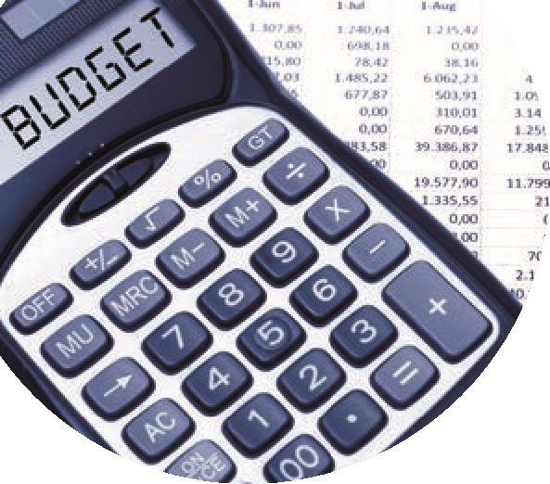

Recording Capital Project in Sage 50 Checklist
 | Task | Sage 50 Bank Module | Handouts
 | Gather Project Info | - All paperwork – ref & file in Sage  - Budget information for template  - Check Chart of account codes – (contribution to Fixed Asset Codes) in Sage 50 | Template to assist with  reporting on Capital  Project  Supplier App Form
Overview of Capital Projects

Register contract in ROS
 |  | - Create a department in Sage 50 for the Cap Project & use add documents feature.
 | Relevant Contract Invoice | - Record VAT Journal in Sage 50
 |  | - Record DE Grant in Sage 50 (Use Dept)
 | Notify payment to Revenue
 | Making payment to Supplier | - Record payment in Sage 50  Record RCT journal in Sage 50 if appropriate | Could consider using the  Supplier’s ledger for the  project
 | VAT Return | Record VAT Payment in VAT control account in Sage 50
 | RCT Return | Record RCT payment in RCT Control account in Sage 50
 | Regular monthly reporting from Sage 50 | - Review nominal activity to check for accuracy of recording
 | Cap Project reporting template | - Run department report to report on & to monitor capital Project

