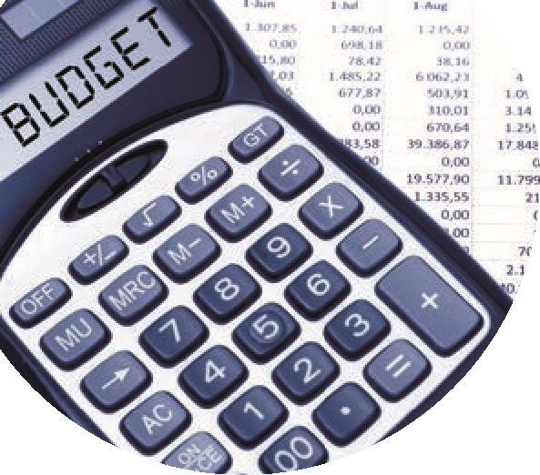

Monthly Accounts preparation 2022/2023 Sage 50 Checklist
 | Follow up | Detail
1 | Check Financial Year in Sage 50 | Settings / Financial Year
 | It should be starting September 2022 | 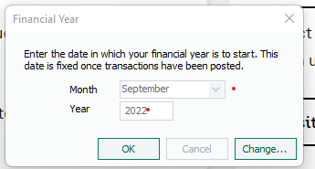
2 | Are the Y/E adjustments recorded in Sage 50 at 31.8.2022 | Journal entries to ensure TB in Sage 50 agrees to the Accountants TB
3 | Is the Trial Balance brought forward agreeing to the annual accounts? | Fixed Assets, Current Assets, Current Liabilities,  Reserves
4 | 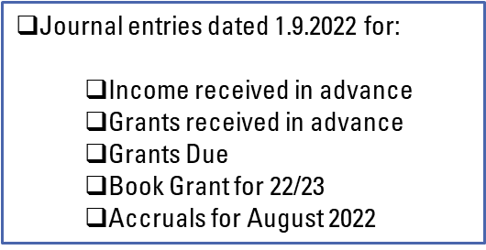 | Review Balance sheet at 28.2.2023
5 | How much of the digital divide grant was unspent at 1.9.2022  Is there a balance in code 2179?
6 | Assign a department reference to the balance for the DDG and remember to use it for any related costs this year
7 | Run a nominal activity report for the balances under the accruals section in the balance sheet to cover period 01.9.2022 – 28.02.2023  Look at the movements and verify to the Balance sheet at 28.2.2023
8 | Check the balances on nominal codes 2182 – 2184  Is the DE payment reflected in here ?  Are the balances nil @ 28.2.2023
9 | Verify balance in code 2105 at 28.2.2023 – is the balance nil?
10 | Check the school chart of accounts to ensure that it is in agreement with the latest FSSU coa.  Ensure that the new fixed asset addition codes are created and are being used for capital additions | In preparation for next month’s webinar covering Capital expenditure

