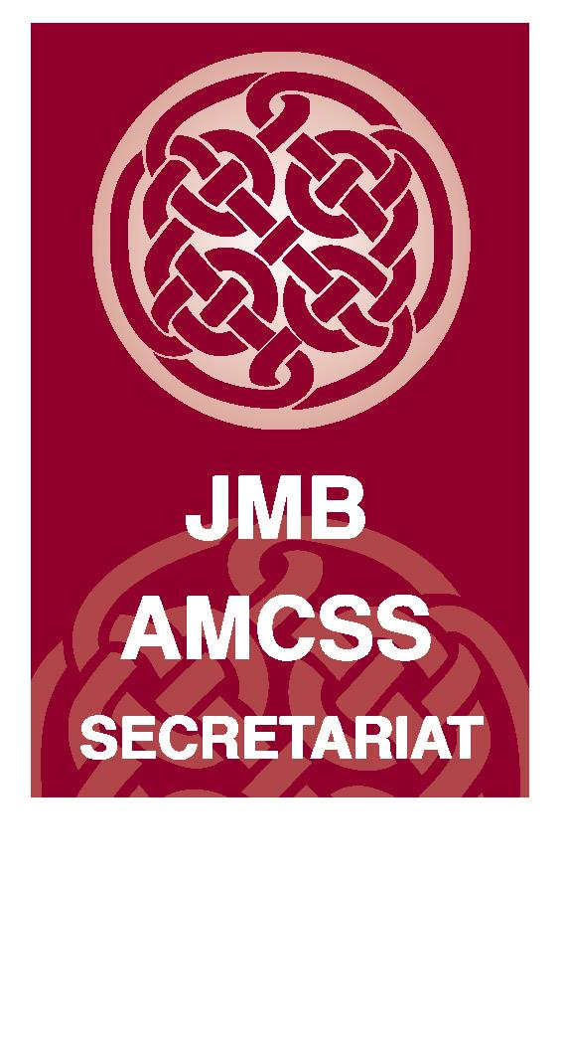
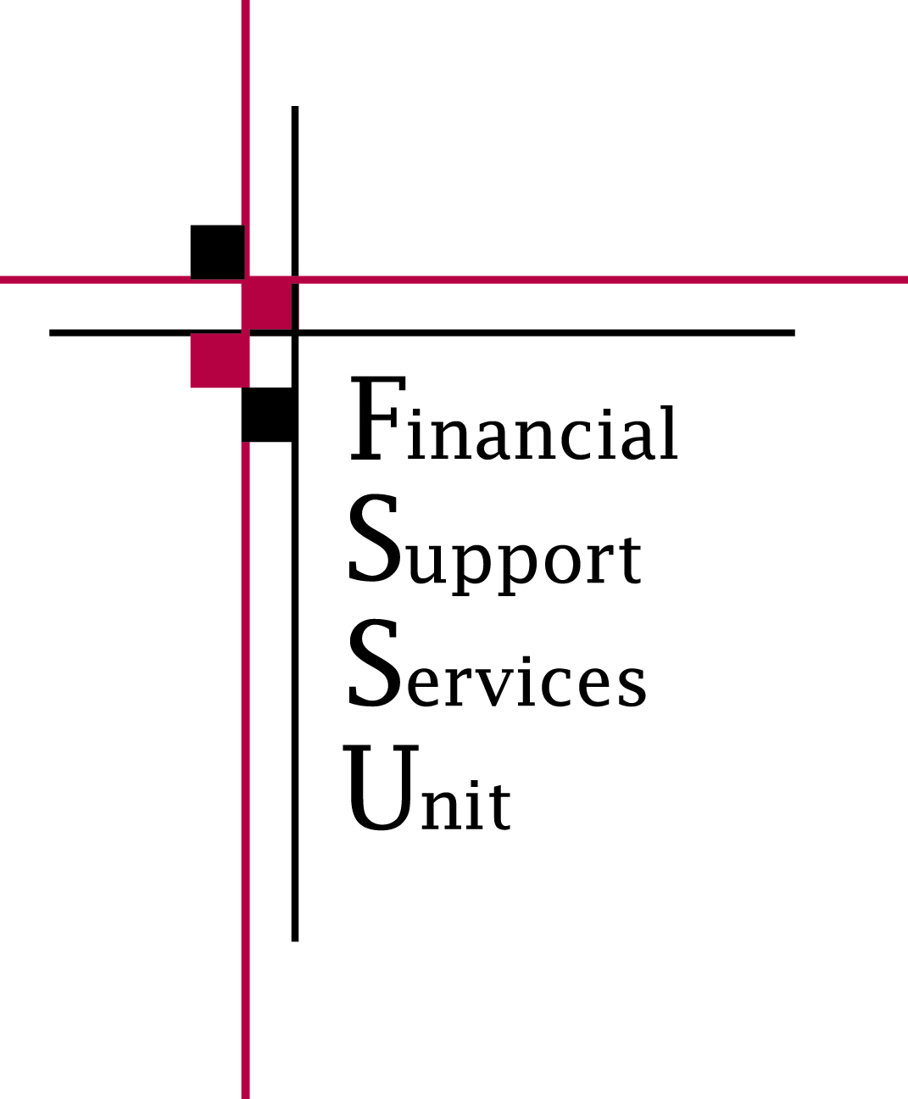

2012/2013 Financial Guideline 12

State Examination Payments

Payment Arrangements for School Appointed Superintendents, Examinations Aides and Art Models at the 2013 Certificate Examinations

The State Examinations Commission (SEC) will refund the costs of employment in respect of the following examinations positions:

- School appointed examination superintendents for LCA, LCVP, Aural and Practical examinations and for superintendents of Special Centre’s under the scheme of reasonable accommodations (including those who also act as readers/scribes).

- Examinations Aides

- Art Models

New rules for Superintendents of special examination centres

There is no change to the rates of pay for 2013. The SEC has confirmed that the change to the method of calculating payment to superintendents of special examination centres with a session rate instead of a daily rate continues to apply.

With effect from the 2013 examinations, superintendents of special examination centres will be paid by reference to the number of examination sessions that they superintend. The special centre superintending rate is now €42.75 per session for SNAs and €56.02 per session for non SNAs (i.e. a superintendent of a special centre who superintends two sessions in any day will continue to be paid the equivalent of the previous daily rate).

A session is regarded as a morning or an afternoon examination sitting. Aural tests are considered part of the examination session of the subject to which they relate and are not regarded as an examination session in their own right.

Payment for School Appointed Superintendents, Examinations Aides and Art Models

- Application of Tax, USC and PRSI

It is the responsibility of individual schools to administer PAYE, PRSI and USC for the above appointments and to pay over any monies deducted in respect of same to the Revenue Commissioners.

The appointment of superintendents and examination aides is covered under Class J PRSI. The rate of employer PRSI under this class is 0.5%. The SEC will refund to schools the employer PRSI at the appropriate rate in respect of superintendents and examination aides.

- Public Service Pension Related Deduction (PRD)

Earnings in respect of work conducted for, or on behalf of, the SEC are subject to the Public Service Pension Related Deduction (PRD) as provided for in the Financial Emergency Measures in the Public Interest Act 2009. The following section details how PRD should be applied by schools in respect of locally appointed superintendents and examinations aides. This section also provides details of how deductions in respect of PRD should be reported to the SEC.

- Determining Applicability of/Exemption from PRD

The Emergency Measures in the Public Interest Act 2009 defines a person to whom the PRD applies as a person who
i. is a public servant, and,
ii. is a member of a public service pension scheme, or,
iii. is entitled to a benefit under a public service pension scheme, or,
iv. receives a payment in lieu of membership of a public service pension scheme

An individual appointed by a school as a superintendent or an examinations aide who meets any of the criteria above is subject to PRD.

Exemption: An individual who does not meet any of these criteria is considered exempt from PRD. Individuals wishing to claim an exemption from PRD should complete the exemption form as provided by the SEC. Completed forms are to be retained by the school for audit purposes. They should not be returned to the SEC. Payments to exempt individuals for examinations work may be made without applying PRD.

The SEC expects that a significant proportion of locally appointed examinations personnel, as serving SNAs and teachers, will be liable to PRD.

- Determining the Rate(s) of PRD to Apply

If an individual appointed as a superintendent or examinations aide is subject to PRD, by reference to the criteria set out above, then the school must determine the rate of PRD to apply by reference to the individual’s employment or pension status as follows:

• The school is the individual’s main employer: If the individual is otherwise employed by the school (e.g., as a teacher or SNA) then the school should deduct PRD at the appropriate rate by reference to the aggregate earnings in the employment, including the earnings in respect of examinations work. The PRD rates are set out in the table below.

N.B. The individual is considered to be employed by the school even if the Department of Education and Skills is the paying agent.

• The school is the individual’s subsidiary employer: If the individual is only employed by the school for the purpose of the state examinations, then the school is required to deduct PRD at a rate of 10.5%, from all of their earnings in respect of examinations work.

• The individual is in receipt of a public service pension: The school should apply PRD to earnings in respect of their examinations work only by reference to the rates and thresholds set out in the table below.

The rates of PRD that apply to all public service income are as follows

€0- €15,000 | 0%
€15,001 - €20,000 | 5%
€20,001 - €60,000 | 10%
€60,000 | 10.5%

The Financial Emergency Measures in the Public Interest Act 2009 which gives legal effect to the PRD states that employers who do not deduct the PRD as required will have any public sector grants due to them reduced by the amount of the PRD liability.

The SEC will reimburse schools for the employment of locally appointed examinations personnel net of PRD.

3. Claims for Payment

All claims for reimbursement of the cost of employing locally appointed examinations personnel must be made on the appropriate forms and must be accompanied by signed receipts. All schools are required to record the individual PRD amounts deducted from payments to school appointed superintendents and examination aides on the relevant SEC claim forms. All claims for reimbursement must also be accompanied by the new composite recording form OS 2013. This form facilitates the recording of all PRD deductions from such staff and will enable the SEC to make the necessary exchequer PRD returns.

The SEC will only accept claims for reimbursement on SEC forms of account, the use of non SEC forms will result in the entire claim being returned to the school. All claims for reimbursement must be signed by the recipient in the school and the school principal.

Sample Claim Forms are reproduced below for your convenience

N.B. Claims that are completed incorrectly, inaccurately and /or unsigned will be returned in their entirety to the school

Fergus Dunne, Director,
JMB Financial Support Services Unit.

June 2013

S30/13

PUBLIC SERVICE PENSION RELATED DEDUCTION (PRD)

Please read the Circular S30/13 – ‘Payment Arrangements for Locally Appointed Superintendents, Examinations Aides and Art Models at the 2013 Certificate Examinations’ prior to completing this form. Complete the form in block capitals with the exception of the signature fields. Complete Section A in all cases and Section B or C as appropriate. The School / VEC reserves the right to verify the information submitted.

SECTION A. PERSONAL DETAILS

First Name: _______________________________ Surname: ____________________________
(BLOCK CAPITALS) (BLOCK CAPITALS

PPSN

Address: _____________________________________________________________________________

Mobile Number: _______________________ Email: _____________________________________

SECTION B. CLAIM FOR EXEMPTION FROM PRD

I hereby claim exemption from PRD as outlined in Circular S30/13 – ‘Payment Arrangements for Locally Appointed Superintendents, Examinations Aides and Art Models at the 2013 Certificate Examinations’ as I declare that;

A. I am not employed in any other public service body (full-time, part-time or otherwise).

AND

B. I am not a member of a Public Service Pension Scheme.
NOR
Am I in receipt of a pension from a Public Service Pension Scheme
NOR
Have I opted out of a Public Service Pension Scheme
NOR
Do I receive payment in lieu of membership of a Public Service Pension Scheme

Signature:____________________________________ Date: __ / __ / ____

SECTION C: DESIGNATION OF SCHOOL / VEC AS EITHER MAIN OR SUBSIDIARY EMPLOYMENT FOR THE PURPOSES OF PRD

Having read and understood Circular S30/13 – ‘Payment Arrangements for Locally Appointed Superintendents, Examinations Aides and Art Models at the 2013 Certificate Examinations’, I hereby designate the following school / VEC _________________________________ as my *____________________________ employment for the purposes of PRD. *insert Main or Subsidiary as appropriate

I confirm that I am not in employment and am liable to PRD.
`
Signature:____________________________________ Date: __ / __ / ____
Notes for completion of Form SP1 2013

Superintendents of Special Centres

- This form is to claim reimbursement of payments made to Superintendents of special centres during the state examinations in June.

- Please note the format of the SP1 2012 form has been changed and a separate form must now be completed for each.
- All information requested must be supplied. The SP1 form will be returned if any information is not provided. individual superintendent.

- The Separate Centre number (issued by Reasonable Accommodation Section, SEC) must be provided. (candidate number only for practicals).

- Please insert the examination number of the candidate who is assigned to the special centre.

- Please indicate whether the person is acting as a Reader/Superintendent/Scribe.

- Form SP1 2013 to be completed for all special centres

- Meeting Day for superintendents and candidates (where relevant) prior to June written exams, to take place on the Tuesday.

- The rate applicable is per session (Please refer to Appendix A of Circular S27/A and indicate whether SNA rate or Non SNA rate applies). prior to the start of the examinations only.

- Please tick whether the session took place in the morning or afternoon or tick both if the full day applies (a tick in the AM/PM box will suffice. It is not necessary to fill in times).

- The Total Amount is the session rate multiplied by the amount of sessions.

- The Sub-Total is the total amount for each day added together.

- Minus PRD (Nil can be inserted here if PRD does not apply). Please refer to Circular S27/12 Page 4 for PRD rates that apply to all Public Service Income.

- EMPLOYER PRSI (Class J1) is then added to this figure to give the Total Amount due to the school in respect of that Superintendent.

- The form must be then signed and dated by the superintendent/reader/scribe and they must confirm whether they are an Approved SNA or Non-SNA.

- Finally, the declaration must be completed and signed by the Principal.

E.A.1 2012
EXAMINATIONS AIDE
SCHOOL REIMBURSEMENT FORM 2013

Name of School: ___________________________ School Roll No: _____________

1. TOTAL NUMBER OF CANDIDATES SITTING STATE EXAMINATIONS
COMMISSION EXAMINATIONS IN 2012: ___________

2. NUMBER OF DAYS FOR WHICH REMUNERATION IS SOUGHT: ___________

3. DATES FOR WHICH REIMBURSEMENT IS SOUGHT:

__________________________________________________

4. EXAMINATIONS AIDE NAME: ___________________________________________________

5. EXAMINATIONS AIDE P. P. S. NUMBER: _______________________

6. AMOUNT PAID TO EXAMINATIONS AIDE:

No. of Days _______ @ daily rate of €136.04 = € _______

LESS PRD= €__________

= € __________

+ 0.5% PRSI = € __________

Total Pay = € ___________

SIGNATURE:_______________________________________________ DATE: _______________

SIGNATURE OF EXAMINATIONS AIDE (TO ACKNOWLEDGE RECEIPT)
Declaration
I certify I have paid the Revenue Commissioners the employers PRSI of €_______.
I now claim a total refund of €_______ (which includes the Employer PRSI @ class J1)
I certify I have made Public Service Pension Related Deduction of €_______
or
I certify that the Examination Aide named is Exempt from PRD

SIGNATURE OF PRINCIPAL: _________________________________ DATE: ________________

